**Project Planning Phase**

**Project Planning Template (Product Backlog, Sprint Planning, Stories, Story points)**

|  |  |
| --- | --- |
| Date | 26 June 2025 |
| Team ID | LTVIP2025TMID35580 |
| Project Name | Citizen AI – Intelligent Citizen Engagement Platform |
| Maximum Marks | 5 Marks |

**Product Backlog, Sprint Schedule, and Estimation (4 Marks)**

Use the below template to create product backlog and sprint schedule

| **Sprint** | **Functional Requirement (Epic)** | **User Story Number** | **User Story / Task** | **Story Points** | **Priority** | **Team Members** |
| --- | --- | --- | --- | --- | --- | --- |
| Sprint-1 | |  | | --- | |  |  |  | | --- | | Chat Interface Setup | | USN-1 | As a user, I can enter a prompt and get a response from the chatbot | 3 | High | Jakkula Kavya |
| Sprint-1 |  | USN-2 | As a developer, I can load the IBM Granite model from Hugging Face | 3 | High | |  | | --- | |  |  |  | | --- | | Kandavalli Ashok | |
| Sprint-1 |  | USN-3 | As a user, I can interact via Gradio's simple UI | 2 | High | Jannu Eeswari |
| Sprint-2 | Functional Output | USN-4 | As a user, I can register for the application through Gmail As a user, I get accurate responses to questions like “How to apply for a license” | 3 | High | Jakkula Sai Venkata Sathwik |
| Sprint-2 |  | USN-5 | As a developer, I can store the model locally to improve load time | 2 | Medium | Kandavalli Ashok |
| Sprint-3 | Future Feature Planning | USN-6 | As a user, I should be able to access the chatbot using a public link (Gradio Share) | 2 | High | |  | | --- | | Jakkula Kavya |  |  | | --- | |  | |
| Sprint-4 | Enhancement | USN-7 | As a user, I want multilingual or voice support in the future | 4 | Low | Entire Team |

**Project Tracker, Velocity & Burndown Chart: (4 Marks)**

| **Sprint** | **Total Story Points** | **Duration** | **Sprint Start Date** | **Sprint End Date (Planned)** | **Story Points Completed (as on Planned End Date)** | **Sprint Release Date (Actual)** |
| --- | --- | --- | --- | --- | --- | --- |
| Sprint-1 | 5 | 6 Days | 20 May 2025 | 25 May 2025 | 5 | 25 May 2025 |
| Sprint-2 | 5 | 6 Days | 26 May 2025 | 31 May 2025 | 5 | 31 May 2025 |
| Sprint-3 | 5 | 6 Days | 01 June 2025 | 06 June 2025 | 5 | 06 June 2025 |

**Velocity:**

**Average Velocity = Total Story Points / Days**

=15 Story Points / 18 Days = 0.83 story points/day

**Burndown Chart:**

A burn down chart is a graphical representation of work left to do versus time. It is often used in agile[software development](https://www.visual-paradigm.com/scrum/what-is-agile-software-development/) methodologies such as [Scrum](https://www.visual-paradigm.com/scrum/scrum-in-3-minutes/). However, burn down charts can be applied to any project containing measurable progress over time.

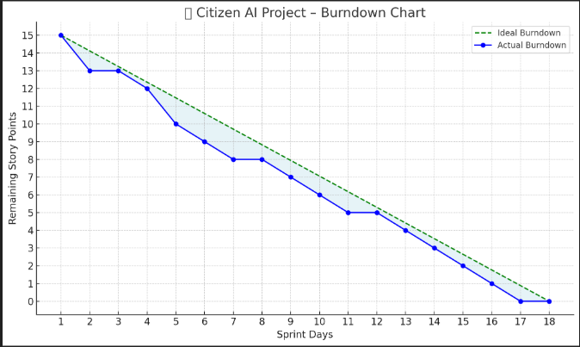

Here is the **Burndown Chart** for your **Citizen AI project**:

* **X-axis** shows the sprint days (1–18).
* **Y-axis** shows the remaining story points (starting from 15 to 0).
* The **green dashed line** is the ideal progress.
* The **blue line with dots** shows your actual progress across the sprint days.